  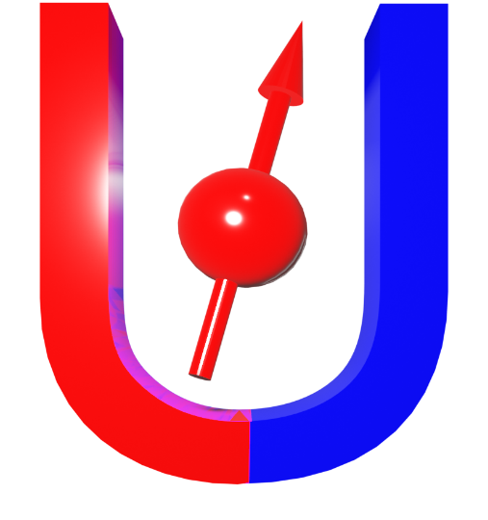 |  | 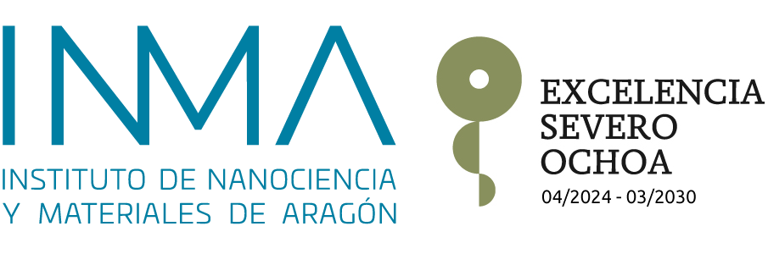    

H2020- Marie Skłodowska-Curie Action Staff Exchange
101007825 – ULTIMATE-I Project
Closing Project

30/03/2026
Time | Presentation | Participant
9:00-9:10 | Introduction | José & Myriam
9:10-9:40 | PI 1: ICN2: Atomic scale defects in epitaxial films of complex layered compounds | José Santiso
9:40-10:00 | Crystallographic control of the inverse spin Hall effect in IrO2 | María Ángeles Laguna  INMA-CSIC-Unizar
10:00-10:20 | Fabrication and characterization of future spintronic devices based on rare-earth iron garnets | Paul Carvajal  UTFSM
10:20-10:50 | Magnetic transitions and spin-polarized two-dimensional electron gas controlled by polarization switching in low dimensional heterostructures | Solange Di Nápoli/Andrea Barral  CONICET
10:50-11:20 | Coffee Break | All Participants
11:20-12:20 | Plenary 1: Magneto-ionics for data security and brain-inspired memory devices | Jordi Sort
12:20-12:40 | Thermomagnetic Properties of Mixed-Valence Manganite Films Near the Morphotropic Phase Boundary | Dante Peluso  CONICET
12:40-13:00 | Fluorescent Nanotechnology for the Detection of Metal Toxic | Agostina Chapana  UNLP-UnCuyo
 | Fluorescent Nanotechnology for the Detection of Metal Toxic | Agostina Chapana  UNLP-UnCuyo
13:00-14:30 | Lunch Break | All Participants
14:30-17:30 | Alba Visit | All Participants
17:30-19:00 | Round table: PI 2 Management and Closing of Ultimate -I Project (Myriam Aguirre) and Perspectives  Ana María Llois: Importance of Marie Skłodowska-Curie Actions Staff Exchanges in training UNSAM human resources | M Aguirre, L Steren, J. Santiso, AM Llois, S. Di Nápoli, M. Menghini, L. Avilés, M. Granada, …

H2020- Marie Skłodowska-Curie Action Staff Exchange
101007825 – ULTIMATE-I Project
Closing Project
31/03/2026
Time | Presentation | Participant
9:00-10:00 | Plenary 2: Transport in Quantum Materials @ IMDEA Nanociencia | Mariela Menghini  IMDEA
10:00-10:30 | PI 3: CONICET: Exploring quantum and functional materials for spin conversion | Laura Steren  INN-CONICET
10:30-10:50 | Magnetization dynamics and spin current phenomena in YIG and Bi:YIG thin films | Lara Solís  CNEA
10:50-11:10 | Stress induced perpendicular magnetic anisotropy in rare earth iron garnets thin films | Fernando Soto  UTFSM
11:10-11:40 | Coffee Break | All Participants
11:40-12:00 | Electrical and magnetic properties of hybrid materials based on conductive polymers and ferromagnetic nanoparticles | Gabriel Paciaroni  CONICET-UBA
12:00-12:20 | Transport Properties in Self-Assembled Magnetic Nanoparticle Systems | Martín Nuñez  UnCuyo-UNIZAR
12:20-12:50 | Neuromorphic devices based on ferroelectric layers and their implementation in a new automated system for training and machine learning. | Miguel Rengifo  UNIZAR
12:50-13:10 | TEM study of changes in amyloid Apo A-I fibres induced by gold plasmonic hyperthermia. | Alejandra Borzi  UNLP-INIFTA
13:10-14:40 | Lunch Break | All Participants
14:40-15:40 | Plenary 3: High-Temperature Superconductors and Hybrid Systems for Energy-Efficient Information and Communication Technologies. | Anna Palau  ICMAB-CSIC
15:40-16:10 | PI 4: CNEA: Spin transport and magnetization dynamics in magnetic microstructures | Luis Avilés  CNEA
16:10-16:30 | Ultrahigh-frequency acoustic modes in metallic Co/Pt superlattices | Mara Granada  CNEA
16:30-16:50 | Caracterización de Aleaciones Elastocalóricas para Sistemas HVAC en Estado Sólido | Gerónimo Castro  CNEA
16:50-17:10 | Revisiting Aluminium Trifluoride Ultrathin Films as Low-Energy Electron-Beam Resist | Gustavo Ruano  CNEA
17:10-17:30 | Kinetic and Spectroscopic Analysis of AlF₃ Film Growth on Graphitic Substrates: Flux and Microstructure Effects on Intercalation and Surface Adsorption | Heidy Betancourt  CONICET
17:30-17:50 | Hyperthermia in tumor cells with nanoparticles. Optimization of the processing for TEM and FIBSEM | Carlos Bértoli  CNEA
20:00 | Gala Dinner | All Participants

H2020- Marie Skłodowska-Curie Action Staff Exchange

Closing Meeting: 101007825 – ULTIMATE-I Project
Seminar Room ICN2, Campus UAB, Bellaterra, Barcelona (Spain)

01/04/2026
Time | Presentation | Participant
9:00-9:30 | PI 5: UTFSMo: Influence of defects and tailoring on the magnetic properties of thin films | Carlos García  UTFSM
9:30-9:50 | Thermoelectric Properties of Sputtered Bi₂Te₃ Thin Films | Manolo Cardona  UTFSM
9:50-10:10 | Synthesis and Characterization of Metal Coordinated N-Graphene Quantum Dots | Leandro López  UNLP-INIFTA
10:10-10:30 | Design and Fabrication of Pt/Graphene/YIG Hall-Bar Devices Toward Spin Seebeck Detection | Santiago Barrionuevo  UNLP-INIFTA
10:30-10:50 | Self-induced inverse spin Hall effect in disordered FePt thin films | José Luis Ampuero Torres  IJL-UL
 | FINAL Coffee Break | All Participants

